**Infosys Logical Questions and Answers**

**Q1:**Directions: Each question below has two statements following it. Decide if the statement suffices to answer the question. Choices are:

A) If only I is sufficient

B) If only II is sufficient

C) If both are required

D) If each can answer independently

E) If data is inadequate

Is integer x divisible by 12?

I) x is the product of three consecutive positive integers

II) x is the product of three consecutive even integers

**Ans 1**: B

**Explanation:**

(I) **Not sufficient.** x could be the product of 1, 2, and 3 (x = 6), but it could also be the product of 12, 13, and 14 (and therefore clearly divisible by 12). This statement does tell us that x is divisible by 6 (in any set of three consecutive integers, at least one will be even and at least one will be divisible by 2), but it is not sufficient to say whether x is divisible by 12.

(I) **Sufficient.** In any set of three consecutive even integers, at least one will be divisible by 3. Algebraically, you can see this by noting these integers as 2a * (2a + 2) * (2a + 4). Factor out the 2s: 2(a) * 2(a + 1) * 2(a + 2), and you’ll see that you have as factors 23 * three consecutive integers. Clearly, then, one of those three consecutive integers will be divisible by 3, and you will have at least four factors of 2 in that group. This is sufficient to prove that the product will contain the prime factorization of 12: 2 * 2 * 3.

**Q2:**Directions: Each question below has two statements following it. Decide if the statement suffices to answer the question. Choices are:

A) If only I is sufficient

B) If only II is sufficient

C) If both are required

D) If each can answer independently

E) If data is inadequate

If a = 5, what is value of b + c?

I) a is the average of the set {a, b, c}

II) ab + ac = 10

**Ans 2**: D

**Explanation:**

(I) **Sufficient**. This statement tells us that (a + b + c)/3 = 5, which means that a + b + c = 15. We know that a = 5, so b + c must equal 10.

(II) **Sufficient**. Knowing that a = 5, this statement tells us that 5b + 5c = 10. Divide both sides by 5 to find that b + c = 2.

**Q 3:**Directions: Each question below has two statements following it. Decide if the statement suffices to answer the question. Choices are:

A) If only I is sufficient

B) If only II is sufficient

C) If both are required

D) If each can answer independently

E) If data is inadequate

A pet store sells only dogs and cats. If the ratio of dogs to cats is 3:2, how many dogs are in the pet store?

(I) If the number of cats were to double, the ratio would be 3:4.

(II) If 3 cats were added, there would be more cats than dogs.

**Ans 3:** E

**Explanation:**

(I) Not sufficient. This statement adds no new information; the current totals are 3x dogs and 2x cats, so doubling the number of cats would just make it 2(2x) = 4x cats. We already know that that new ratio would be 3:4.

(II) Not sufficient. But close! With a ratio of 3:2, the possibilities are 3 dogs and 2 cats; 6 dogs and 4 cats; 9 dogs and 6 cats; etc. In each of the first two cases, three more cats would tip the ratio so that there were more cats: 3 dogs and 2+3 catsà more cats. And 6 dogs and 4 + 3 cats = more cats. Because there are two potential solutions, the statement is insufficient.

**Q 4:**

**Statements:**

No stone is metal.

Some metals are papers.

All papers are glass.

**Conclusions:**

I. All stones being glass is a possibility.

II. No stone is paper.

A. If only conclusion I follows.

B. If only conclusion II follows.

C. If either conclusion I or conclusion II follows.

D. If neither conclusion I nor conclusion II follows.

E. If both conclusion I and conclusion II follow

**Ans 4**: A

**Explanation:**

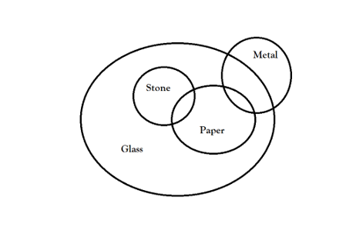

From this we can see that all stones being glass is a possibility and no stone is paper need not be true. So, option a) is the correct answer.

**Q 5:**

**Statements:**

Some sticks are lamps.

Some flowers are lamps.

Some lamps are dresses.

All dresses are shirts.

**Conclusions:**

I. Some shirts are sticks.

II. Some shirts are flowers.

III. Some flowers are sticks.

IV. Some dresses are sticks.

A) None follows

B) Only I follows

C) Only II follows

D) Only III follows

E) Only IV follows

**Ans 5**: A

**Explanation:**

Based on the Venn diagram, none of the conclusions are implied by the statements.

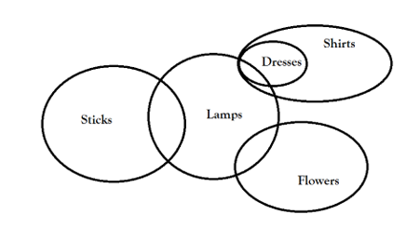

**Q 6**:

**Statements:**

Some benches are walls.

All walls are houses.

Some houses are jungles.

All jungles are roads.

**Conclusions:**

I. Some roads are benches.

II. Some jungles are walls.

III. Some houses are benches.

IV. Some roads are houses.

A)  Only land II follow

B) Only I and III follow

C) Only III and IV follow

D) Only II, III and IV follow

E) None of these

**Ans 6**: C

**Explanation:**

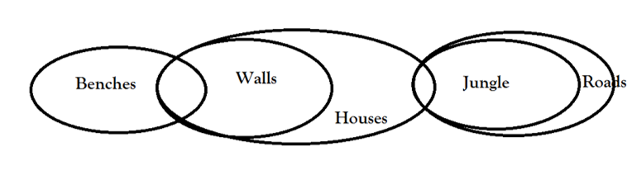

Based on the following Venn diagram, only conclusions 3 and 4 are implied.

**Q 7**: Direction: The following table gives the sales of batteries manufactured by company over the years. Study the table and answer the question that follows:

NUMBER OF DIFFERENT TYPES OF BATTERIES SOLD BY A COMPANY OVER THE YEARS (NUMBERS IN THOUSAND)

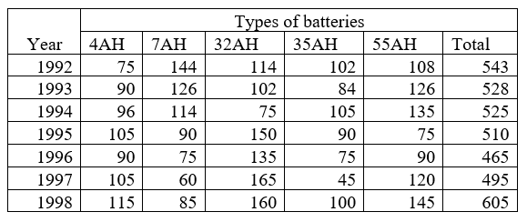

The total sales of all the seven years are the maximum for which battery?

(A) 4AH

(B) 7AH

(C) 32AH

(D) 35AH

(E) 55AH

**Ans 7**: C

**Explanation:**

The total sales (in thousand) of all the seven years for various batteries are :

For 4AH = 75 + 90 + 96 + 105 + 90 + 105 + 115 = 676

For 7AH = 144 + 126 + 114 + 90 + 75 + 60 + 85 = 694

For 32AH = 114 + 102 + 75 + 150 + 135 + 165 + 160 = 901

For 35AH = 102 + 84 + 105 + 90 + 75 + 45 + 100 = 601

For 55AH = 108 + 126 + 135 + 75 + 90 + 120 + 145 = 799

Clearly, sales are maximum in case of 32AH batteries

**Q 8:**Direction: The following table gives the sales of batteries manufactured by company over the years. Study the table and answer the question that follows:

NUMBER OF DIFFERENT TYPES OF BATTERIES SOLD BY A COMPANY OVER THE YEARS (NUMBERS IN THOUSAND)

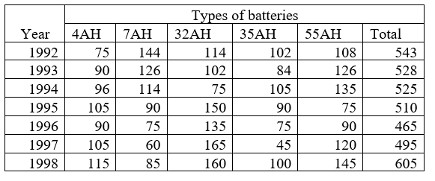

What is the difference in the number of 35AH batteries sold in 1993 and 1997?

(A) 24000

(B) 28000

(C) 35000

(D) 39000

(E) 4200

**Ans 8**: D

**Explanation:**

Required difference = [(84 – 45) × 1000]=39000.

**Q 9:**Direction: The following table gives the sales of batteries manufactured by company over the years. Study the table and answer the question that follows:

NUMBER OF DIFFERENT TYPES OF BATTERIES SOLD BY A COMPANY OVER THE YEARS (NUMBERS IN THOUSAND)

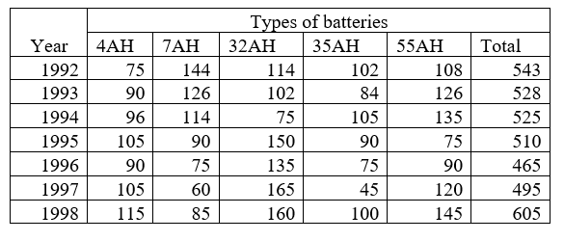

In the case of which battery there was a continuous decrease in sales from 1992 to 1997?

(A) 4AH

(B) 7AH

(C) 32AH

(D) 35AH

(E) 55AH

**Ans 9**: B

**Explanation:**

 From the table, it is clear that the sales of 7AH batteries have been decreasing continuously from 1992 to 1997.